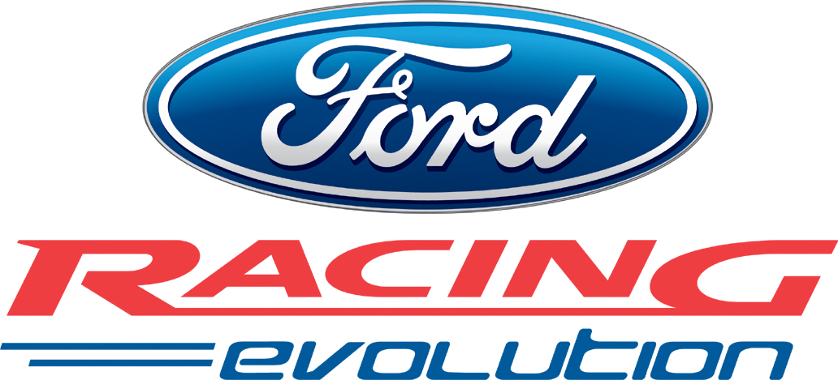

Empire Joins Forces with Ford

Ford is without a doubt one of the biggest and most famous brands in the world. With the Ford brand comes one of the biggest and most famous product ranges ever. Ford Racing Evolution takes this amazing range of vehicles, from the 1968 Mustang to the latest Mustang GT Concept car. If you know about the cars, the racing or the famous Blue Oval – then you deserve to take control and have the drive of your life!

With so many cars at your disposal we’ll make sure you have a whole host of challenges to put them through. Standard racing around tracks and ovals will be there for you to tear around; off road courses to test your Rally skills and even some more diverse inner city chases and curvy country lanes to test your driving skills. And of course, there’ll be plenty of two player challenges to pit you against too.

But like so many things in life, if you want to get your hands on all the Ford cars available, then you’ll have to earn them. Each track, race and fun pursuit will have its respective challenge, which will unlock a new car if you can beat it. All of these vehicles will have their strong points but it will up to you to master them.

Ford Racing Evolution features:

- A wide range of Ford vehicles combined with Razorworks’ advanced rendering, physics and AI technology
- Drive 32 cars including the Ford GT, The New 2004 F-150, SVT Lightning, SVT Mustang Cobra, 2002 Thunderbird, Mustang Mach III, Gran Torino, 1955 Thunderbird, 1971 Mustang, Focus Rally, and 49 Coupe
- Ford vehicles of the past and the present to control. Race a 1968 Mustang and the latest Mustang GT Concept car
- Unlock cars to add them to your ‘Ford Collection’, where they become available for racing
- Pick-up-and-play car handling and easily accessible interface cater to the mass-market casual gamers
- Diverse themed tracks including: Road Tracks, Off-Road Tracks, Jungle, Desert and Ovals
- Challenge Mode offers varied gameplay. Standard Race, Duel, Drafting, Racing Line, Time Trials and Elimination modes are offered, as well as a special driving skills section.

Release: PlayStation®2, Microsoft Xbox™ and PC CD-ROM scheduled for 31st October ‘03.
Age Rating: 3+
Developer: Razorworks

For further information, please contact:

Doug Johns Tel: +44 (0) 1243 671767
PR Manager – 1Up Media Email: doug@1-upmedia.com

Chris East Tel: +44 (0) 20 7343 7447
Head of Marketing & PR Empire Interactive Email: chris.east@empire.co.uk

